

INDIAN SCHOOL DARSAIT
(Muscat, Sultanate of Oman)

COMPUTER SCIENCE (083)
(2025-26)

PROJECT REPORT

TOPIC
PRODUCT MANAGEMENT SYSTEM

Submitted by: Navaneeth Sunith
Class & Sec : XII A

INDIAN SCHOOL DARSAIT

MUSCAT, SULTANATE OF OMAN



CERTIFICATE

PROJECT REPORT
COMPUTER SCIENCE
(Code - 083)

It is hereby certified that ------------------------------------------------------------------------------------------------------------------- Reg. No. ------------------------------------------ of class XII Science has carried out this project work entitled ------------------------------------------------------------------------------------------------------------------------------------------------------------as per the syllabus prescribed by the Central Board of Secondary Education, New Delhi, India for the year 2025 - 2026.

Teacher In-Charge

Principal School Seal
Date:

External Examiner

TABLE OF CONTENTS

Sl. No. | Topic | Page No.
 | Acknowledgment | 4
 | Introduction | 5
 | System Requirements | 7
 | Source Code | 8
 | Output Screen | 11
 | Conclusion | 16
 | Bibliography | 17

ACKNOWLEDGEMENT

In the accomplishment of this project many people have extended their unstinted support. I take this opportunity to place on record the noble hearts who have been directly or indirectly associated with this project.

At the outset, I thank the Almighty God for blessing me with good health to complete this project on time. I express my heartfelt gratitude to my Principal, Mr. Amar Srivastava, Vice Principal Mrs. Shamshad Hamza and other administrators for providing me with the facilities I required.

I owe my gratitude to Mrs. Shalini Aggarwal, my Computer Science Teacher and project guide who gave me the golden opportunity to do this challenging Project in Python. Her guidance and monitoring throughout the work have helped me complete the task.

My special thanks go to Mrs. Sara Alex (HoD - ICT) who encouraged me to aspire for perfection in the project and for giving me her valuable advice. I would like to thank all the teachers in the Department of ICT who have taught me over the years.

I wish to express my deep gratitude to my parents who have been instrumental in helping me to submit this project successfully.

Finally, I would like to thank all my friends for their valuable support and encouragement in one way or the other extended to me on the road to the completion of this project.

Navaneeth Sunith
CLASS: XII A
2025-26

INTRODUCTION

- General introduction on the project:

- In any busy supermarket, keeping track of products is a critical task. Managing stock levels, prices, and expiry dates manually can be difficult and often leads to errors. This "Supermarket Product Management System" project is designed to solve these challenges by providing a simple and efficient digital solution for inventory management.
- This system is built to be used by supermarket staff. It helps them perform their daily tasks easily through a simple menu.
- The project uses Python for the front-end menu and MySQL as the back-end database to store all the product information securely. The connection between Python and MySQL is made possible using the mysql.connector library.

- Modules:
Modules used in this project are:
- Mysql.connector
This module is used to establish the connection between the Python program and the MySQL database.
- datetime
This module is used to get the current date, which helps in checking for expired products.

- SQL Tables:
The SQL tabkes used in this projct are:
- Student
This table has the columns – ProductID, ProductName, Price, Quantity, and ExpiryDate. It is used to store all the details for every product available in the supermarket.

- Working Description:
When the program starts, the user must enter a password to access the main menu. The project has the following features:
- Add a Product: Allows the user to enter the details of a new product and add it to the database.

- See All Products: Displays a neat list of all the products currently stored in the database.

- Check for Expired Products: Compares the expiry date of products with the current date and lists all items that have expired.

- Remove a Product: Lets the user delete a product's record from the database using its Product ID.

- Exit: Closes the program.

SYSTEM REQUIREMENTS

- Hardware requirements
- OS: Windows 7& Above
- Processor: Pentium Series or Anthlon Series
- RAM: 2GB+
- Storage Space: Minimum 10MB

- Software requirements
- Windows OS/MAC OS/Linux Distros
- Python 2.7 and above
- MYSQL Database
- Word Document

SOURCE CODE

import mysql.connector
from datetime import datetime

con = mysql.connector.connect(
host='localhost',
user='root',
password='your_password',
database='supermarket'
)
c = con.cursor()

c.execute("CREATE TABLE IF NOT EXISTS Products (ProductID VARCHAR(10) PRIMARY KEY, ProductName VARCHAR(50), Price INT, Quantity INT, ExpiryDate DATE);")

def add_product():
print("\n--- Add a New Product ---")
pid = input("Enter Product ID (e.g., 101): ")
pname = input("Enter Product Name: ")
price = input("Enter Price: ")
qty = input("Enter Quantity: ")
exp_date = input("Enter Expiry Date (YYYY-MM-DD): ")

sql = "INSERT INTO Products VALUES (%s, %s, %s, %s, %s)"
val = (pid, pname, price, qty, exp_date)

c.execute(sql, val)
con.commit()
print("Product was added successfully!")

def display_products():
print("\n--- All Products in the Store ---")
c.execute("SELECT * FROM Products")
all_products = c.fetchall()

print("%-12s %-20s %-10s %-10s %-15s" % ("PRODUCT ID", "PRODUCT NAME", "PRICE", "QUANTITY", "EXPIRES ON"))
print("-" * 75)

for product in all_products:
print("%-12s %-20s %-10s %-10s %-15s" % (product[0], product[1], product[2], product[3], str(product[4])))

def check_expiry():
print("\n--- Checking for Expired Products ---")
today = datetime.now().date()

sql = "SELECT ProductName, ExpiryDate FROM Products WHERE ExpiryDate < %s"
c.execute(sql, (today,))
expired_items = c.fetchall()

if not expired_items:
print("Good news! No products have expired.")
else:
print("The following products have expired:")
for item in expired_items:
print(f"- {item[0]} (Expired on: {item[1]})")

def remove_product():
print("\n--- Remove a Product ---")
pid = input("Enter the Product ID you want to remove: ")

sql = "DELETE FROM Products WHERE ProductID = %s"
c.execute(sql, (pid,))
con.commit()

if c.rowcount > 0:
print("Product has been removed successfully!")
else:
print("Sorry, that Product ID was not found.")

def main_menu():
while True:
print("\n<<<< SUPERMARKET MENU >>>>")
print("1. Add a Product")
print("2. See All Products")
print("3. Check for Expired Products")
print("4. Remove a Product")
print("5. Exit")

choice = input("\nWhat would you like to do? (1-5): ")

if choice == '1':
add_product()
elif choice == '2':
display_products()
elif choice == '3':
check_expiry()
elif choice == '4':
remove_product()
elif choice == '5':
print("\nGoodbye!")
break
else:

print("\nInvalid choice. Please pick a number from the menu.")

password = input("Enter Password: ")

if password == 'admin':
print("\nWelcome!")
main_menu()
else:
print("Incorrect Password.")

con.close()

OUTPUT SCREEN

- SQL TABLES USED

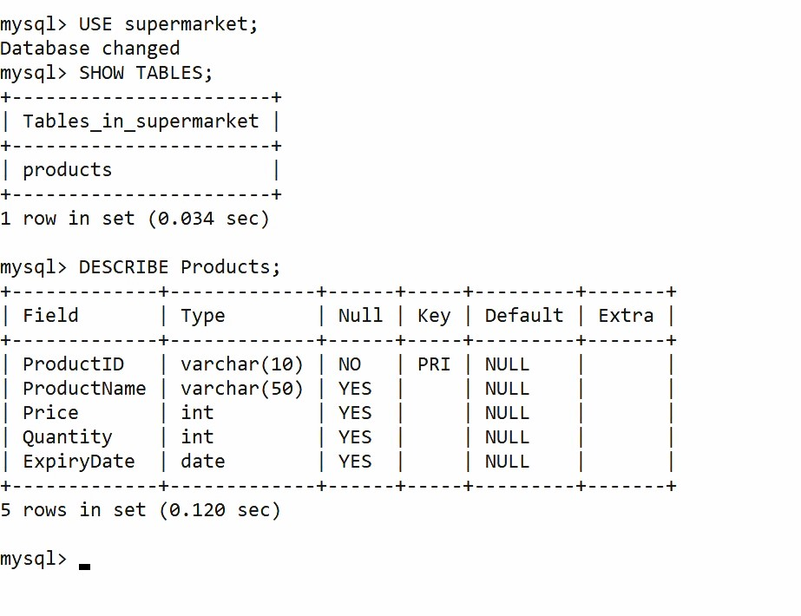

- PYTHON OUTPUT SCREEN SHOTS

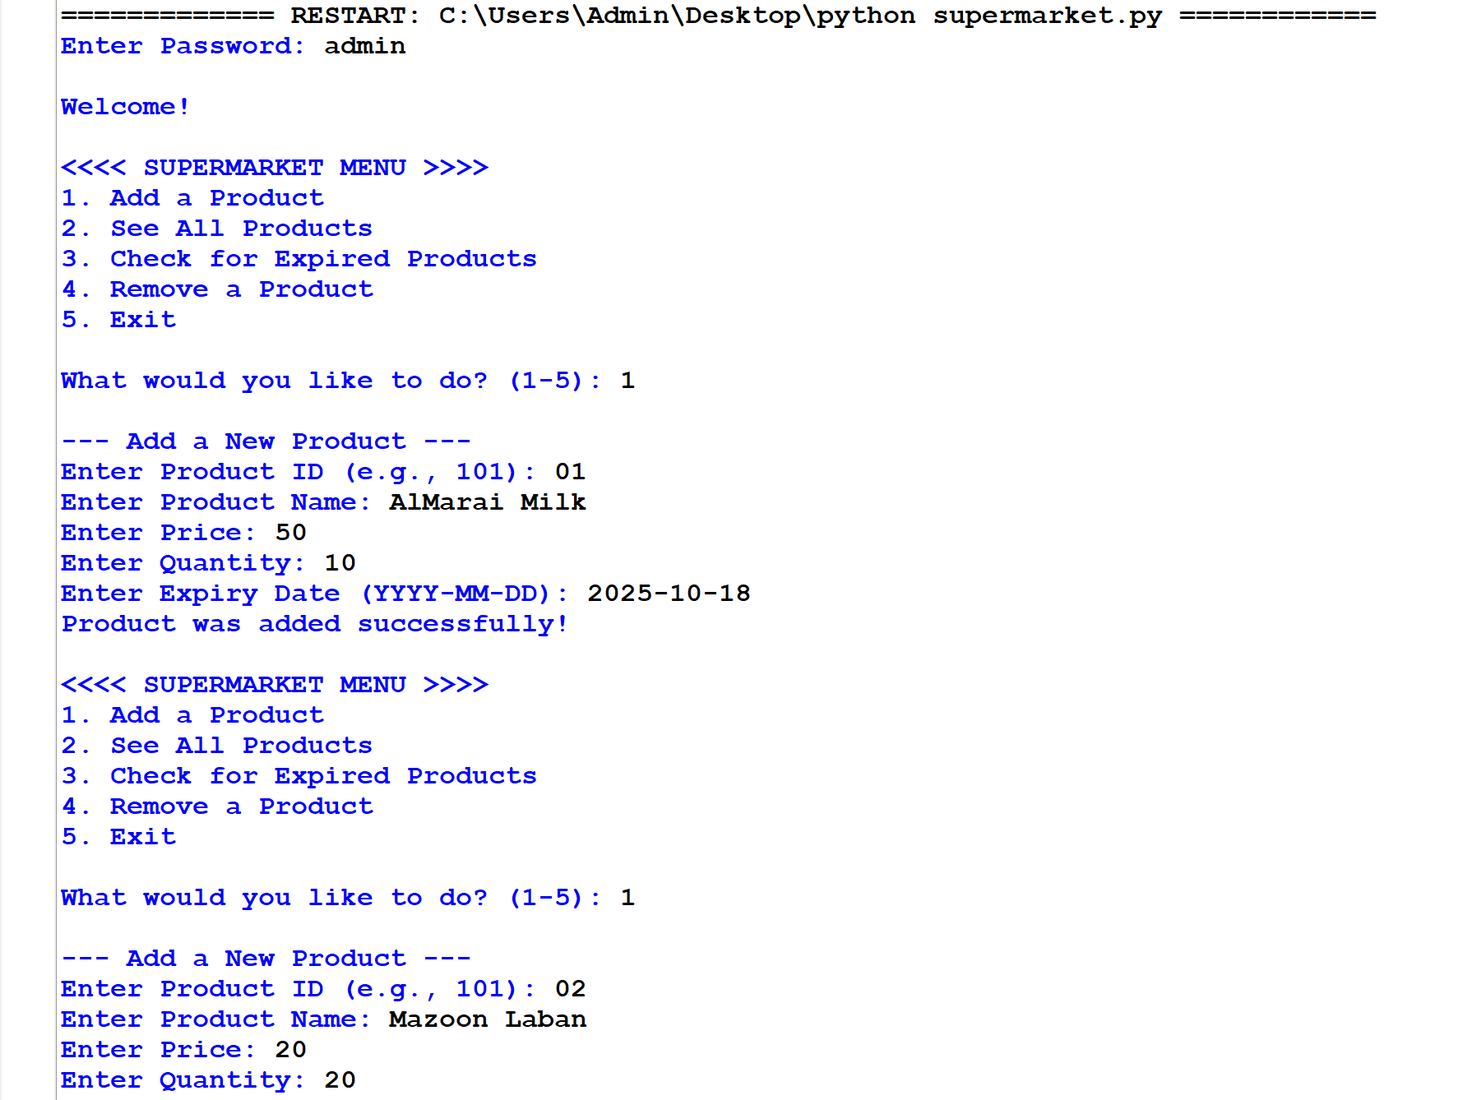
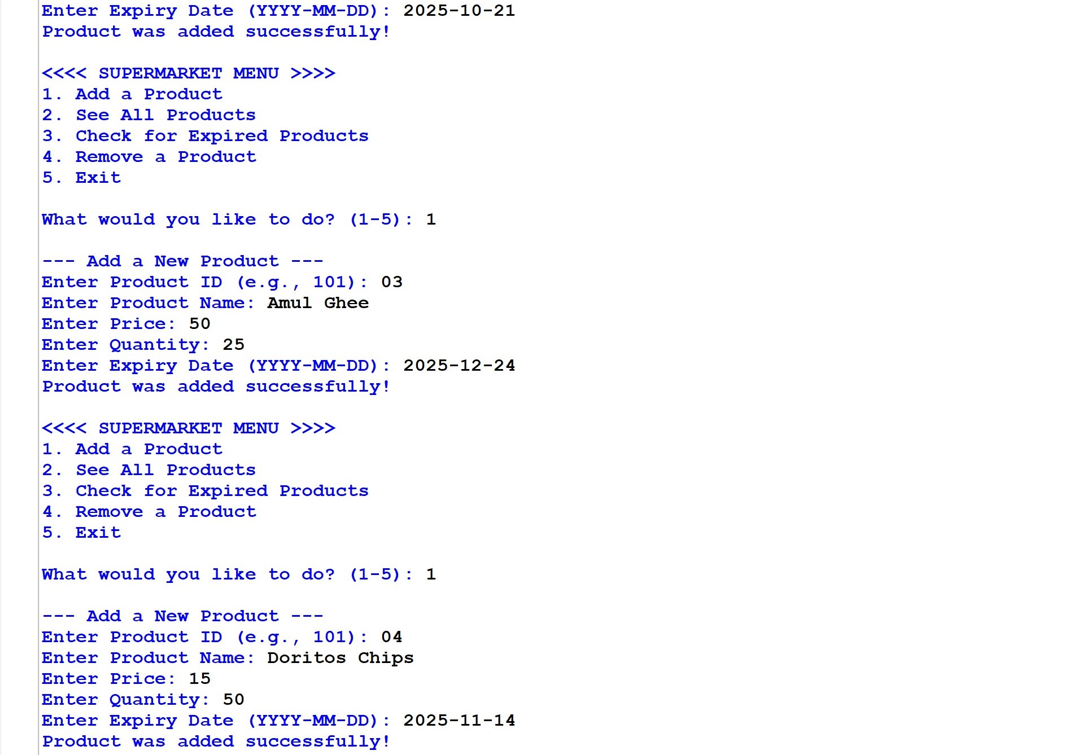



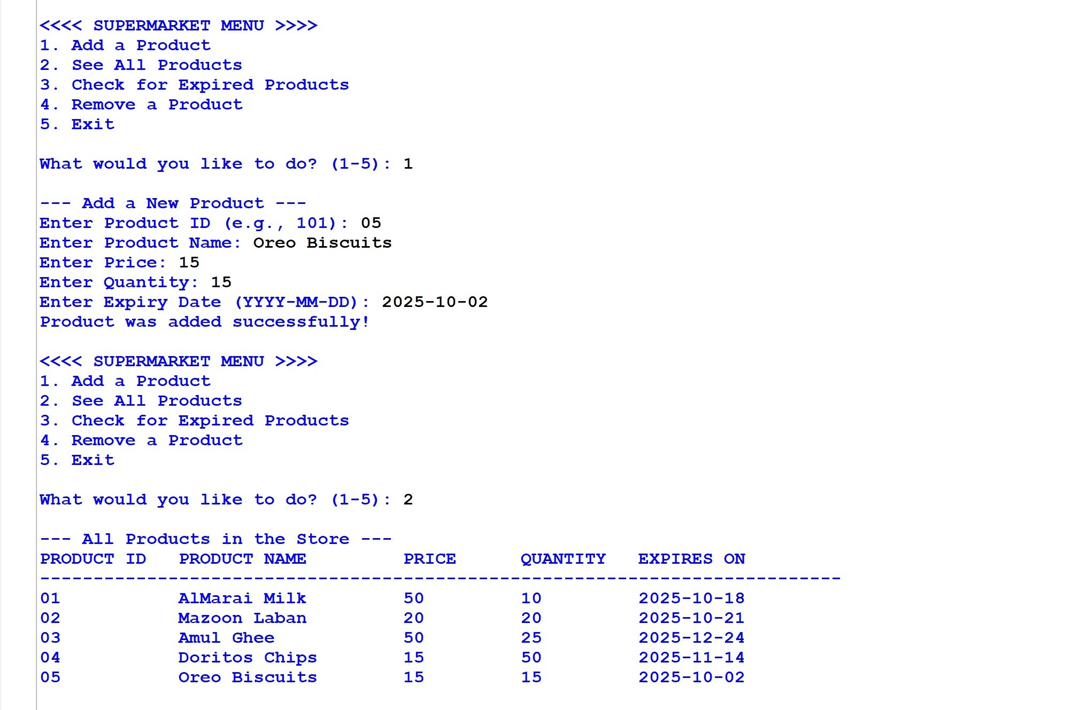

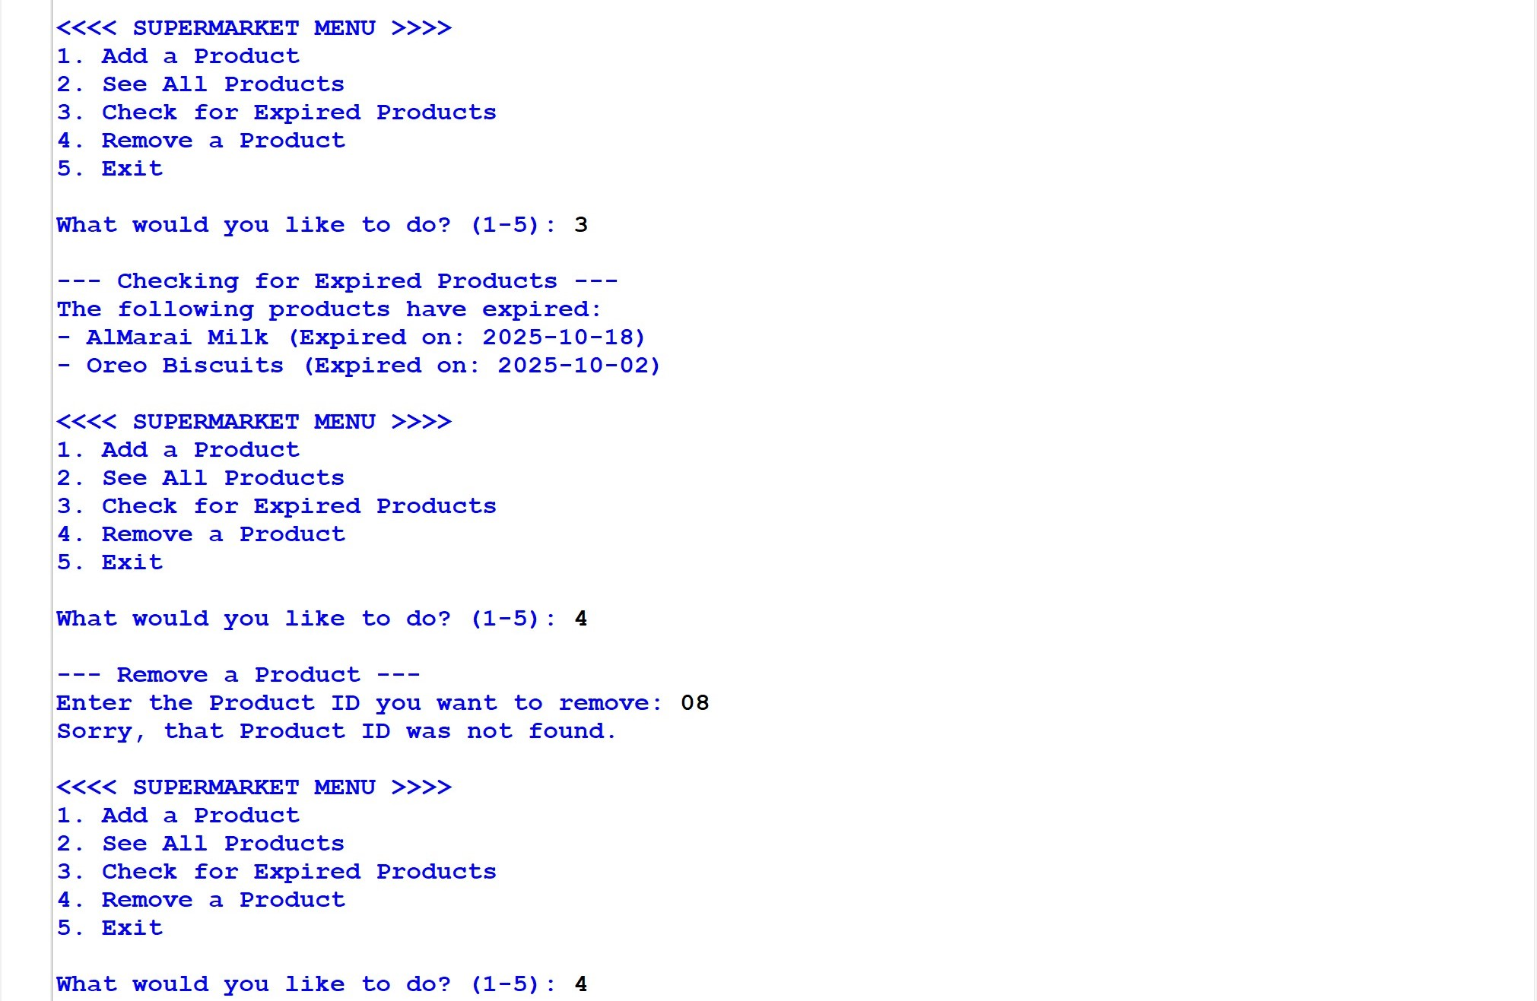
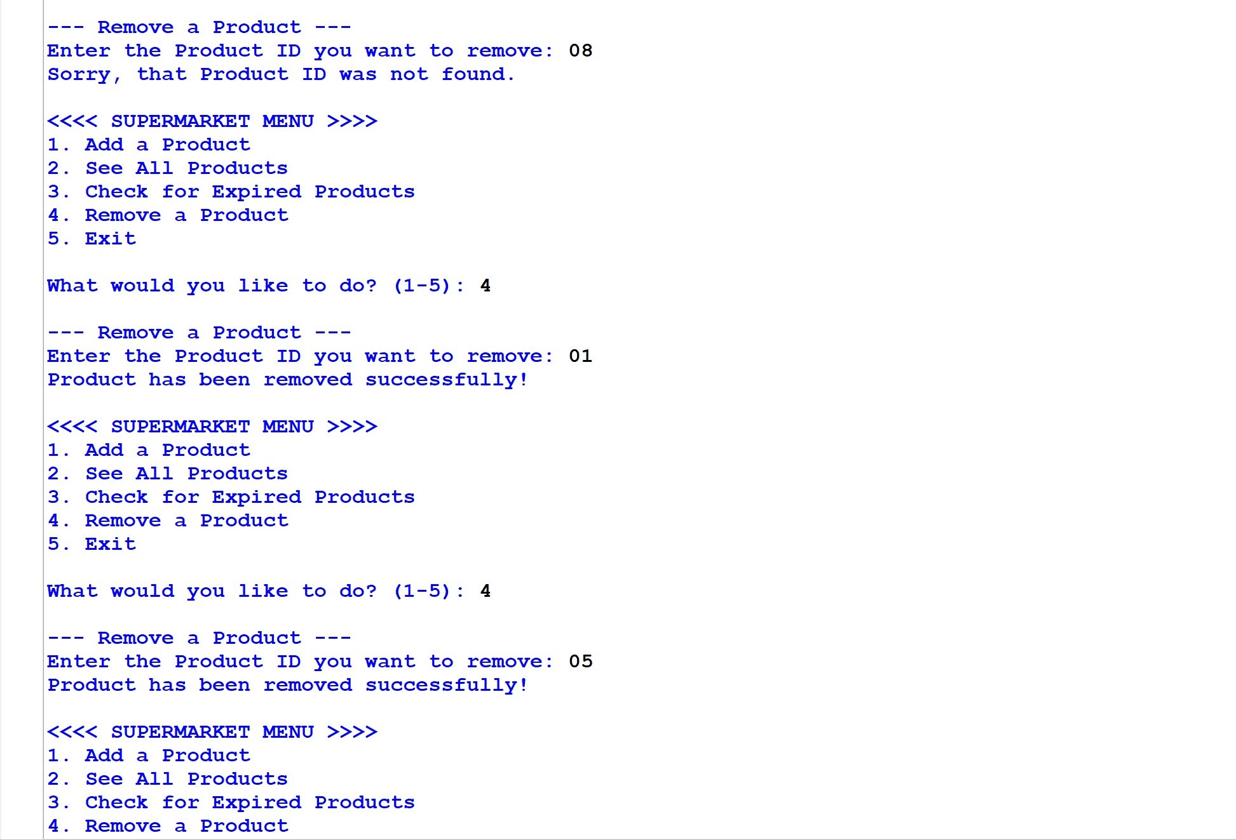


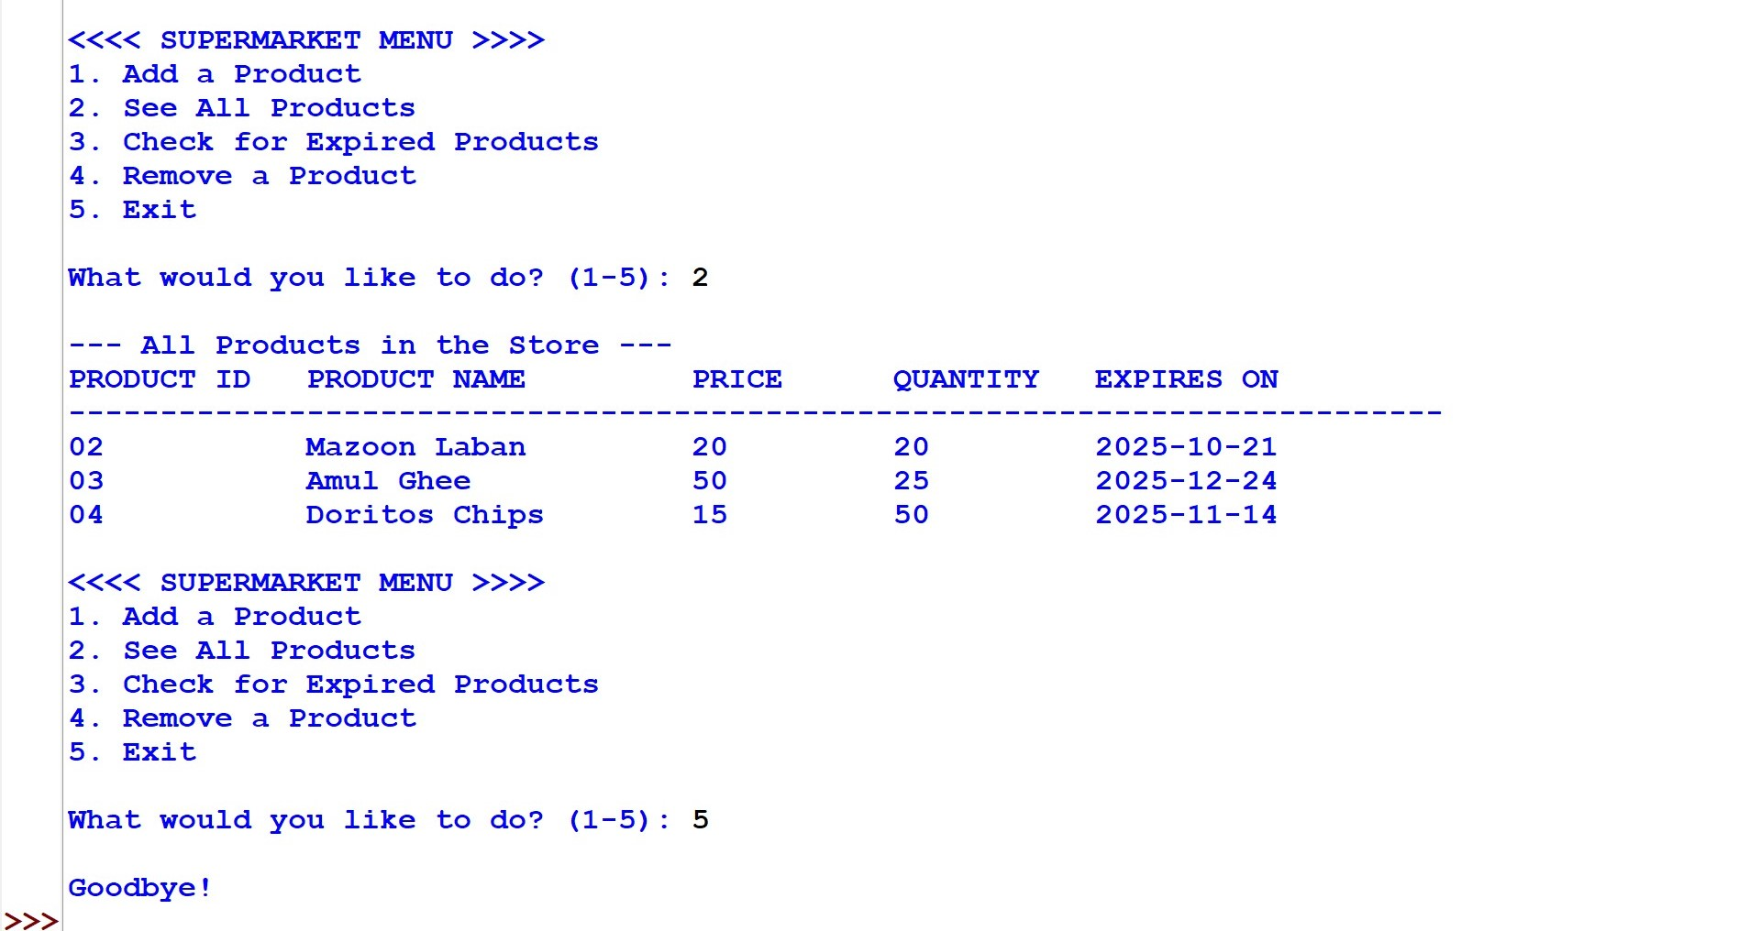

CONCLUSION

This project is made to replace the manual work of writing down product details and managing inventory on paper. It helps make the process much faster, reduces the chance of human errors, and allows for better management of the store's products, saving valuable time and resources.

In the future, the project can be expanded to include more features. For example, a billing system for customers could be added, which would automatically update the stock levels. Additional features like adding online payment options and making the system accessible over the internet can also be incorporated to make it more powerful.

BIBLIOGRAPHY

- Reference Books:

- Computer Science with Python Class XI & XII, Sumita Arora
- Computer Science with Python Class XI & XII, Reeta Sahoo
- Computer Science with Python Class XI & XII, Preeti Arora

- Websites:
- https://w3resource.com/
- https://www.wikipedia.org/
- https://dev.mysql.com/doc/connector-python/en/

